CPSC 4660 Project Proposal

Robert Hoover

2013-10-03

The goal of my CPSC 4660 Project is to create a program that will convert a relational database into an XML document. Once I have successfully converted an EER model to a XML document I plan on running queries on both and comparing the run times to find any differences. For this project I will be following a research paper written by Joseph Fong, Francis Pang, and Chris Bloor. This paper outlines the key steps in achieving a proper conversion from an EER model to a XML document.

The mapping of an existing EER model to an XML document involves multiple steps. These steps are outlined fully in the attached paper, however I will briefly summarize them.

Step 1: Entity 🡪 Element

Every entity in an EER model can be mapped to an Element in a XML scheme.

Step 2: Relationship -🡪 Href

A relationship in EER model can be mapped to a hypertext reference in an XML schema.

Step 3: Generalisation 🡪 SuperType

To indicate that the content model of a subset inherits the content model of a superset the superType copies the content model of the referenced element type.

Step 4: Categorisation 🡪 GroupOrder SuperType

To indicate that the content model of the subset inherits one of the content models of a superset, GroupOrder superType copies one of the content models of the referenced element type.

Step 5: Aggregation 🡪 Archetypes

An aggregation is an entity that is composed of multiple component entities.

Step 6: Cardinality 🡪 “ONEORMORE”

A cardinality means an element contains one or more occurrences of another element.

Step 7: Participation 🡪 Occurs

Total or partial participation between two entities in an EER model are mapped to “required”/”implied” in a XML schema.

For my project, I will be using the relational schema provided in the research paper. As an alternative I would be open to be using a provided schema and data. By using the provided schema I will be able to verify that my program is able to handle all types of an EER model such as aggregation and specialisation.

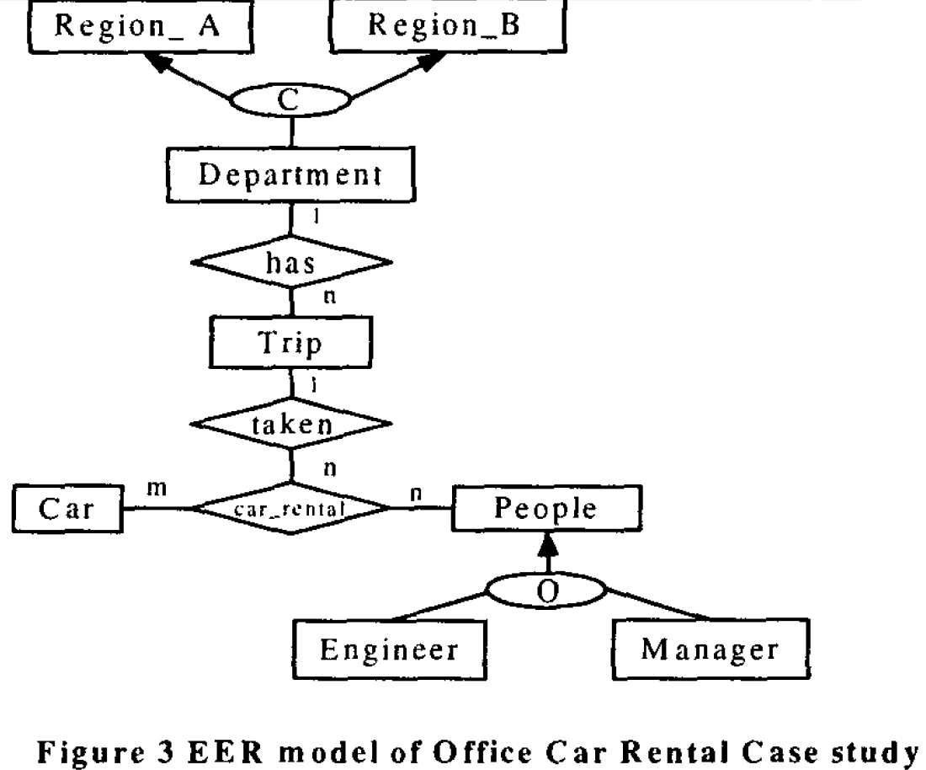

The first step for my project will be to create a relational database in MySQL. I then will input the sample data provided. Once this is complete I can begin writing the required program to convert the relational database into a XML document.

To test the effectiveness of my program, I will compare it to the provided output from the research paper. It will also be possible to run queries on both an XML document as well as a relational database. This will allow me to compute the efficiency of both an XML query and a relational DB query and find any performance differences. With such a small sample set of data I am predicting that both will be equally quick. If time permits I will then create (or be given) another schema and input a larger data set. This will allow for a broader comparison of the time to convert a MySQL database into a complete XML document as well as the comparison on querying each.